SET–20: STOCK ANALYSIS

Data Handling and Visualization – R Programming

Department | AIDS
Course Code / Course Name | DSA0601 / Data Handling and Visualization
Experiment | Data Visualization using R
Name | M.Teja kumar
Register Number | 192424308
Date | 13 October 2026
Day | Tuesday

Experiment Title
Stock Analysis using R Programming

Aim
To analyze the prices of three stocks using R by creating a line chart, calculating the daily percentage change for Stock A and representing it using a bar chart, and displaying the stock-price data in tabular form.

Dataset
Dataset: Stock Prices

Date | Stock A | Stock B | Stock C
2023-01-01 | 100 | 150 | 120
2023-01-02 | 105 | 152 | 118
2023-01-03 | 110 | 148 | 122
The SET-20 experiment specifies four activities: a line chart for the three stock prices, a bar chart for Stock A's daily percentage change, a table of stock prices, and a Tableau dashboard combining the visualizations.

Program 1 – Line Chart of Stock Prices
Aim: To create a line chart to visualize the stock prices of Stock A, Stock B, and Stock C over the given period.
# SET 20 - PROGRAM 1
# Line Chart of Stock Prices

# Create the dataset date <- as.Date(c(
"2023-01-01",
"2023-01-02",
"2023-01-03"
))

stock_a | <- | c(100, | 105, | 110)
stock_b | <- | c(150, | 152, | 148)
stock_c | <- | c(120, | 118, | 122)

stock_data <- data.frame( Date = date,
Stock_A = stock_a, Stock_B = stock_b, Stock_C = stock_c
)

# Plot Stock A plot(
stock_data$Date, stock_data$Stock_A, type = "o",
col = "blue", pch = 16,
lwd = 2,
ylim = range( c(stock_data$Stock_A,
stock_data$Stock_B,

stock_data$Stock_C)
),
main = "Stock Price Trend", xlab = "Date",
ylab = "Stock Price"
)

# Add Stock B lines(
stock_data$Date, stock_data$Stock_B, type = "o",
col = "red", pch = 17,
lwd = 2
)

# Add Stock C lines(
stock_data$Date, stock_data$Stock_C, type = "o",
col = "green", pch = 15,
lwd = 2
)

# Add legend legend(
"topright",
legend = c("Stock A", "Stock B", "Stock C"), col = c("blue", "red", "green"),
pch = c(16, 17, 15),
lwd = 2
)
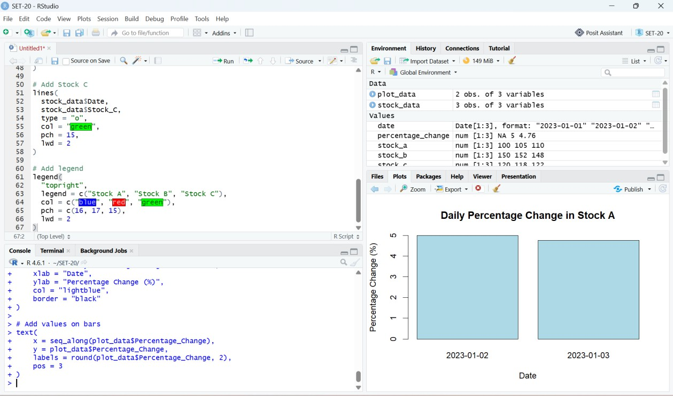

Figure 1: RStudio output – Stock Price Trend

Observation
- Stock A increases from 100 to 110.
- Stock B increases slightly from 150 to 152 and then decreases to 148.
- Stock C decreases from 120 to 118 and then increases to 122.
- Stock B has the highest price among the three stocks during the given period.

Program 2 – Daily Percentage Change in Stock A
Aim: To calculate the daily percentage change in Stock A and represent the result using a bar chart. Formula:
Percentage Change = ((Current Price − Previous Price) / Previous Price) × 100
# SET 20 - PROGRAM 2
# Daily Percentage Change in Stock A

date <- as.Date(c( "2023-01-01",
"2023-01-02",
"2023-01-03"
))
stock_a <- c(100, 105, 110) stock_data <- data.frame(
Date = date, Stock_A = stock_a
)

# Calculate daily percentage change percentage_change <- c(
NA,
diff(stock_data$Stock_A) /
stock_data$Stock_A[-length(stock_data$Stock_A)] * 100
)
stock_data$Percentage_Change <- percentage_change # Display calculated data
print(stock_data)

# Remove first NA value for plotting plot_data <- stock_data[-1, ]

# Create bar chart barplot(
plot_data$Percentage_Change,
names.arg = format(plot_data$Date, "%Y-%m-%d"), main = "Daily Percentage Change in Stock A", xlab = "Date",
ylab = "Percentage Change (%)", col = "lightblue",
border = "black"
)

# Add values on bars text(
x = seq_along(plot_data$Percentage_Change), y = plot_data$Percentage_Change,
labels = round(plot_data$Percentage_Change, 2), pos = 3
)
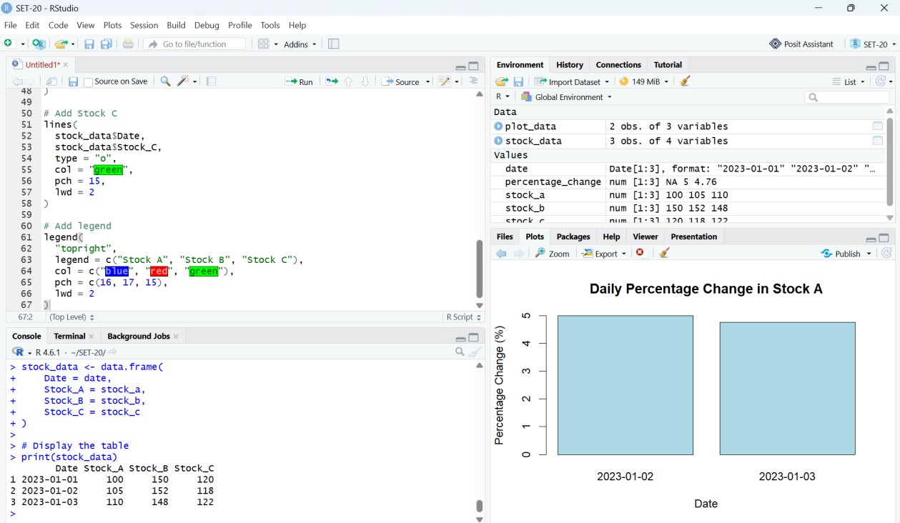

Figure 2: RStudio output – Daily Percentage Change in Stock A

Expected Result
Date | Stock A | Daily Percentage Change
2023-01-02 | 105 | 5.00%
2023-01-03 | 110 | 4.76%

Observation
Stock A shows a positive percentage change on both days. The increase is 5.00% on 2023-01-02 and approximately 4.76% on 2023-01-03, indicating continued upward movement over the period.

Program 3 – Stock Price Data Table
Aim: To build a table displaying the stock prices of all three companies for each date.
# SET 20 - PROGRAM 3
# Stock Price Data Table

date <- as.Date(c( "2023-01-01",
"2023-01-02",
"2023-01-03"
))

stock_a | <- | c(100, | 105, | 110)
stock_b | <- | c(150, | 152, | 148)
stock_c | <- | c(120, | 118, | 122)

stock_data <- data.frame( Date = date,
Stock_A = stock_a, Stock_B = stock_b, Stock_C = stock_c
)

# Display the table print(stock_data)
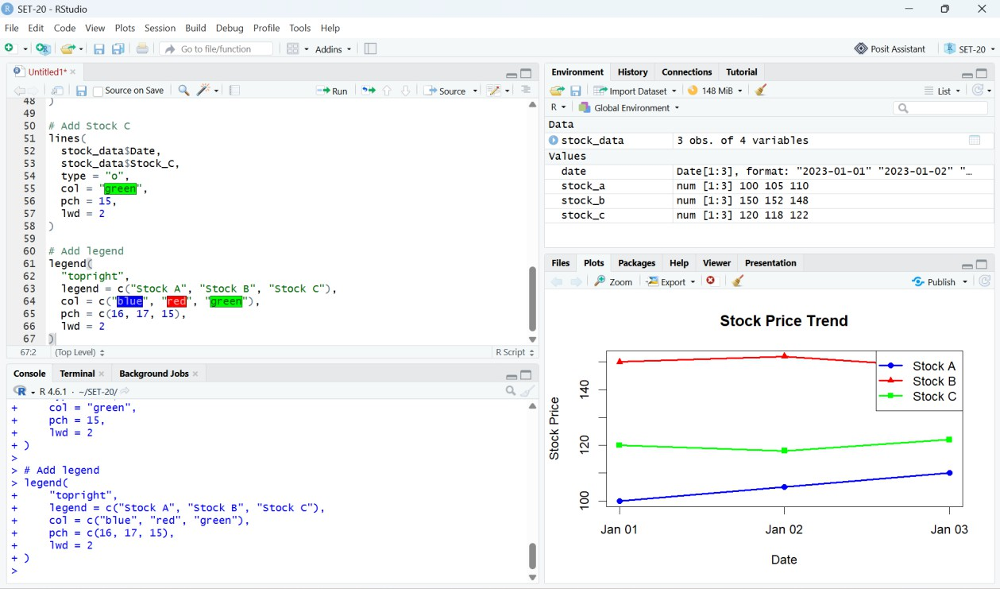

Figure 3: RStudio output – Stock Price Data / RStudio Environment

Expected Output
Date | Stock_A | Stock_B | Stock_C
1 2023-01-01 | 100 | 150 | 120
2 2023-01-02 | 105 | 152 | 118
3 2023-01-03 | 110 | 148 | 122

Program 4 – Tableau Dashboard
The fourth activity in SET-20 is to develop a Tableau dashboard combining the line chart, bar chart, and table for interactive exploration of stock prices.

Tableau Dashboard Components
  - Line Chart: Date on Columns and Stock A, Stock B, and Stock C as the stock-price measures.
  - Bar Chart: Date on Columns and Daily Percentage Change of Stock A on Rows.
  - Table: Date, Stock A, Stock B, and Stock C displayed as a data table.
  - Dashboard: Combine all three sheets into a single interactive dashboard.

Suggested Dashboard Layout
Top section: Stock Price Trend line chart
Bottom-left: Daily Percentage Change in Stock A bar chart Bottom-right: Stock Price Data table

Overall Result
The Stock Analysis experiment was completed using R. A line chart was created to compare Stock A, Stock B, and Stock C, the daily percentage change of Stock A was calculated and visualized using a bar chart, and the stock-price data was displayed in tabular form. The three outputs can be combined with a Tableau dashboard for interactive exploration.

Conclusion
The experiment demonstrates how R can be used to organize stock-price data, visualize trends, calculate percentage changes, and present results clearly. The analysis shows that Stock A had continuous growth during the given three-day period, while Stocks B and C showed small fluctuations.

